MicroGoal
Ideation Phase
Define the Problem Statements

Date
Team ID | SWTID-2026-4956
Project Name | MicroGoal
Maximum Marks

Problem Statement
Many individuals find it difficult to effectively organize and monitor their short-term and long-term goals. Existing solutions are often overly complex, lack proper security, or fail to provide reliable authentication and data protection. Because of these limitations, users may struggle to safely store and manage their personal goal information. Therefore, there is a need for a simple, secure, and efficient backend system that allows users to easily create, update, and access their goals while ensuring proper authentication and data privacy.
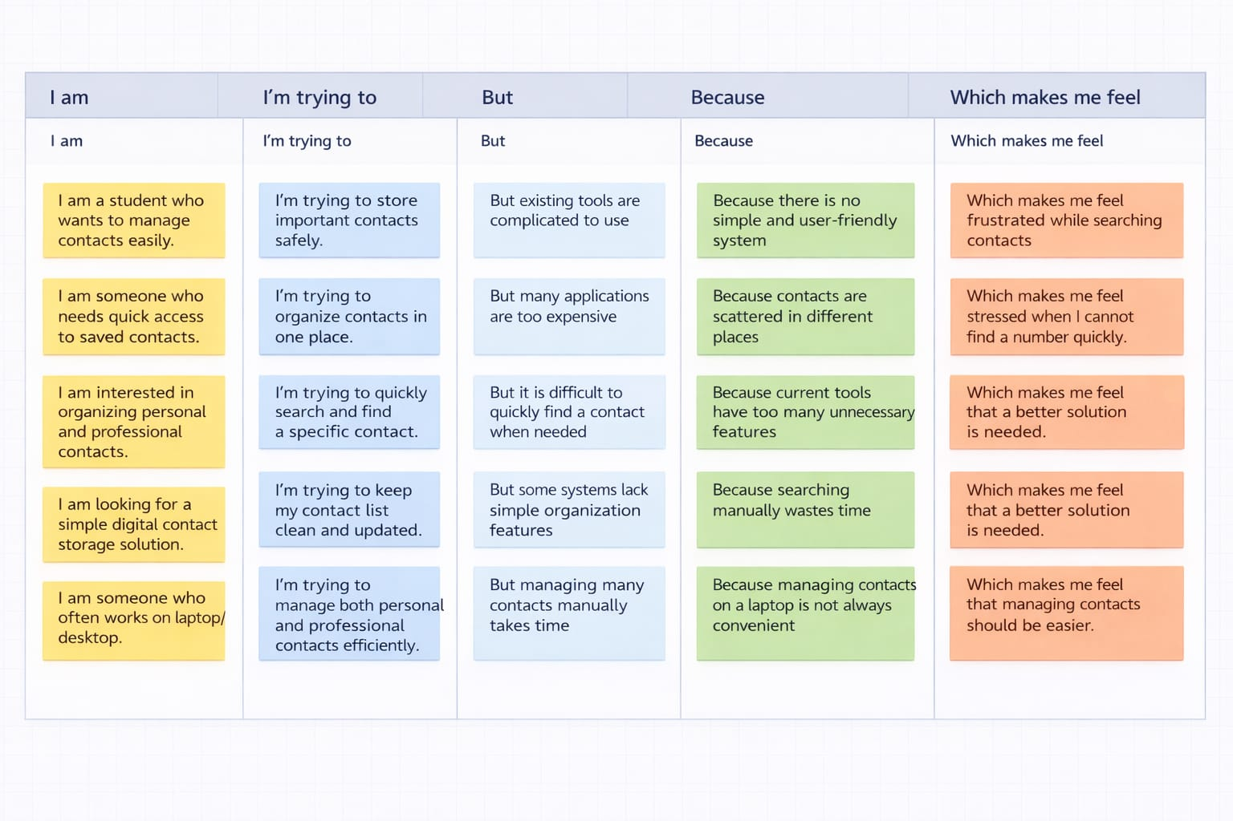

PS ID | I am (Customer) | I'm trying to | But | Because | Which makes me feel
PS-1 | A student | Organize and manage my daily goals online | There is no simple and secure platform | Most available apps are complicated or not safe | Annoyed / Frustrated
PS-2 | A working professional  Unsafe / Insecure | Monitor and update my personal goals | Current systems do not properly secure my information | Authentication features are weak or unavailable | Unsafe / Insecure
PS-3 | A beginner developer  Confused | Create a backend for a goal management system | Setting up authentication is challenging | JWT implementation and middleware configuration are complex | Confused
PS-4 | A user | View and manage my goals anytime | Some applications are not always accessible or reliable | Backend structure is poorly designed | Dissatisfied

